Top 20 web services interview questions and answers

If you need top 7 free ebooks below for your job interview, please visit: 4career.net

• Free ebook: 75 interview questions and answers
• Top 12 secrets to win every job interviews
• 13 types of interview quesitons and how to face them
• Top 8 interview thank you letter samples
• Top 7 cover letter samples
• Top 8 resume samples
• Top 15 ways to search new jobs

Tell me about yourself?
 | This is probably the most asked question in web services interview. It breaks the ice and gets you to talk about something you should be fairly comfortable with. Have something prepared that doesn't sound rehearsed. It's not about you telling your life story and quite frankly, the interviewer just isn't interested. Unless asked to do so, stick to your education, career and current situation. Work through it chronologically from the furthest back to the present.

Define Web Service?

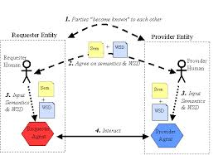 | A web service is a kind of software that is accessible on the Internet. It makes use of the XML messaging system and offers an easy to understand, interface for the end users.

What Can You Do for Us That Other Candidates Can't?
 | What makes you unique? This will take an assessment of your experiences, skills and traits. Summarize concisely: "I have a unique combination of strong technical skills, and the ability to build strong customer relationships. This allows me to use my knowledge and break down information to be more user-friendly."

Give me an example of real web service?
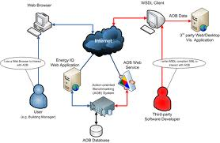 | One example of web services is IBM Web Services browser. You can get it from IBM Alphaworks site. This browser shows various demos related to web services. Basically web services can be used with the help of SOAP, WSDL, and UDDI . All these, provide a plug-and-play interface for using web services such as stock-quote service, a traffic-report service, weather service etc.

How you define web service protocol stack?
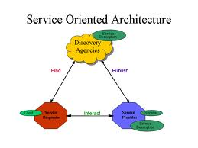 | It is basically set of various protocols that can be used to explore and execute web services. The entire stack has four layers i.e. Service Transport, XML Messaging, Service Description and Service Discovery.

Can you define each of these layers of protocol stack?
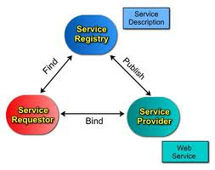 | The Service Transport layer transfer messages between different applications, such as HTTP, SMTP, FTP, and Blocks Extensible Exchange Protocol (BEEP). The XML Messaging layer encodes messages in XML format so that messages can be understood at each end, such as XML-RPC and SOAP. The Service Description layer describes the user interface to a web service, such as WSDL. The Service Discovery layer centralizes services to a common registry and offer simple publish functionality, such as UDDI.

Discuss various approaches to develop SOAP based web service?

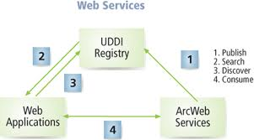 | We can develop SOAP based web service with two different types of approaches such as contract-first and contract-last. In the first approach, the contract is defined first and then the classes are derived from the contract while in the later one, the classes are defined first and then the contract is derived from these classes.

Name browser that allows access to web service?
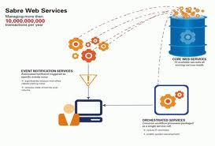 | JavaScript XmlHttpRequest object is required to access web service via browsers. The browsers that support this object are Internet Explorer, Safari and Mozilla-based browsers like FireFox.

How can you document web service?
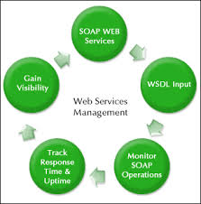 | Web services are contemplated as self-documenting because they provide entire information regarding the available methods and parameters used for XML based standard, known as WSDL. One can also provide more information to explain web services via their own WebService and WebMethod attributes.

What are the situations, when we need ASP.NET web services?
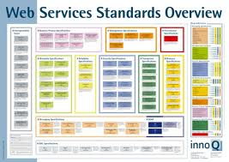 | ASP.NET web services are used when one need to implement three tier architecture in a web service. It allows handy ways to use middle tier components through internet. The main advantage of .NET Web services is that they are capable enough to communicate across firewalls because they use SOAP as transport protocol.

Differentiate between web services, CORBA and DCOM?
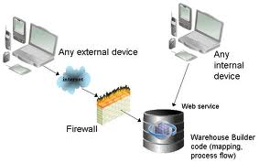 | Web services transfer/receive messages to/from application respectively, via HTTP protocol. It uses XML to encode data.  CORBA and DCOM transfer/receive messages to/from application respectively, via non-standard protocols such as IIOP and RPC.

Can you tell few benefits of web services?
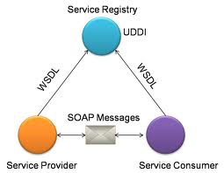 | The biggest advantage of web service is that is supported by wide variety of platforms. Moreover, in near future, web services may spread its boundary and enhance new methods that will provide ease to clients. The enhancement will not affect the clients, even if they offer old methods and parameters

Can you name some standards used in web services?
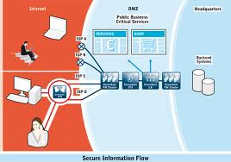 | The standards used in web services are WSDL (used to create interface definition), SOAP (used to structure data), HTTP (communication channels), DISCO (used to create discovery documents) and UDDI (used to create business registries).

Explain in brief, what DISCO is?
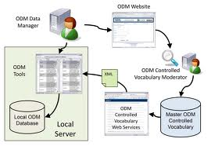 | DISCO means discovery. It groups the list of interrelated web services. The organization that provides web services, issues a DISCO file on its server and that file contains the links of all the provided web services. This standard is good when client knows the company already. Also it can be used within a local network as well.

Explain in brief, what UDDI is?
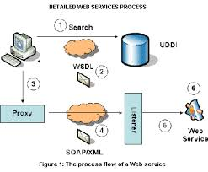 | UDDI (Universal Description, Discovery, and Integration) provides consolidated directory for web services on the internet. Clients use UDDI to find web services as per their business needs. It basically hosts the web services from various companies. In order to share web services, you need to publish it in UDDI.

Explain the .NET web services supported data types?
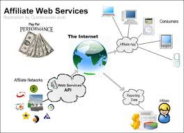 | Net web services uses XML-based standards to transfer/receive information. Thus, .NET web services can only works with data types known by XML schema standard. Like FileSteam, Eventlog etc. are not recognized by the XML schema standards and hence, not supported in web services.

How a .NET web service is consumed?
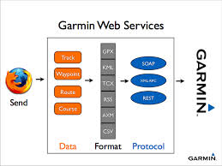 | Since we know that web services are constructed on XML standards. Therefore, clients need to have complete understanding of XML-based messages to interchange messages. Clients can communicate with web services through .NET framework that offers proxy mechanisms. These proxy mechanisms have detailed information regarding data sharing within web services that can be easily used by the clients.

Differentiate between .NET Web Services and .NET Remoting?
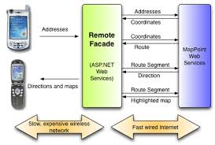 | As far as protocol is concerned, .NET Web Service uses HTTP, while, .NET Remoting uses any protocol i.e. TCP/HTTP/SMTP. When it comes to performance, .NET Remoting is comparatively, faster than.NET Web Service. Also, as .NET Web Services are hosted via IIS, therefore, it is far more reliable than the .NET Remoting.

Explain few disadvantages of Response Caching?
 | Response Caching is useless or incompetent when method accepts extensive amount of values because caching means to store lot of information. Also, if the method depends on external source of information, and that are not provided within the parameters then such methods are bypassed.

what is rest protocol ?
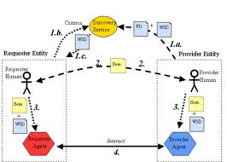 | REST stands for Representational State Transfer. (It is sometimes spelled "ReST".)  EST is a lightweight alternative to mechanisms like RPC (Remote Procedure Calls) and Web Services (SOAP, WSDL, et al.). Later, we will see how much more simple REST is.  Despite being simple, REST is fully-featured; there's basically nothing you can do in Web Services that can't be done with a RESTful architecture.  REST is not a "standard". There will never be a W3C recommendation for REST, for example. And while there are REST programming frameworks, working with REST is so simple that you can often "roll your own" with standard library features in languages like Perl, Java, or C#.

Useful job interview materials:

If you need top free ebooks below for your job interview, please visit: 4career.net

• Free ebook: 75 interview questions and answers
• Top 12 secrets to win every job interviews
• Top 36 situational interview questions
• 440 behavioral interview questions
• 95 management interview questions and answers
• 30 phone interview questions
• Top 8 interview thank you letter samples
• 290 competency based interview questions
• 45 internship interview questions
• Top 7 cover letter samples
• Top 8 resume samples
• Top 15 ways to search new jobs

Top 6 tips for job interview

Tip 1: Do your homework
 |  |  | You'll likely be asked difficult questions during the interview. Preparing the list of likely questions in advance will help you easily transition from question to question.  Spend time researching the company. Look at its site to understand its mission statement, product offerings, and management team. A few hours spent researching before your interview can impress the hiring manager greatly. Read the company's annual report (often posted on the site), review the employee's LinkedIn profiles, and search the company on Google News, to see if they've been mentioned in the media lately. The more you know about a company, the more you'll know how you'll fit in to it.  Ref material: 4career.net/job-interview-checklist-40-points
Tip 2: First impressions
 | When meeting someone for the first time, we instantaneously make our minds about various aspects of their personality.  Prepare and plan that first impression long before you walk in the door. Continue that excellent impression in the days following, and that job could be yours.  Therefore:  - Never arrive late.  - Use positive body language and turn on your charm right from the start.  - Switch off your mobile before you step into the room.  - Look fabulous; dress sharp and make sure you look your best.  - Start the interview with a handshake; give a nice firm press and then some up and down movement.  - Determine to establish a rapport with the interviewer right from the start.  - Always let the interviewer finish speaking before giving your response.  - Express yourself fluently with clarity and precision.  Useful material: 4career.net/top-10-elements-to-make-a-good-first-impression-at-a-job-interview
Tip 3: The “Hidden” Job Market
 |  | Many of us don’t recognize that hidden job market is a huge one and accounts for 2/3 of total job demand from enterprises. This means that if you know how to exploit a hidden job market, you can increase your chance of getting the job up to 300%.  In this section, the author shares his experience and useful tips to exploit hidden job market.  Here are some sources to get penetrating into a hidden job market: Friends; Family; Ex-coworkers; Referral; HR communities; Field communities; Social networks such as Facebook, Twitter…; Last recruitment ads from recruiters; HR emails of potential recruiters…

Tip 4: Do-It-Yourself Interviewing Practice
 | There are a number of ways to prepare for an interview at home without the help of a professional career counselor or coach or a fee-based service.  You can practice interviews all by yourself or recruit friends and family to assist you.  Useful material: 4career.net/free-ebook-75-interview-questions-and-answers

Tip 5: Ask questions
 | Do not leave the interview without ensuring that you know all that you want to know about the position. Once the interview is over, your chance to have important questions answered has ended. Asking questions also can show that you are interested in the job. Be specific with your questions. Ask about the company and the industry. Avoid asking personal questions of the interviewer and avoid asking questions pertaining to politics, religion and the like.  Ref material: 4career.net/25-questions-to-ask-employers-during-your-job-interview

Tip 6: Follow up and send a thank-you note
 | Following up after an interview can help you make a lasting impression and set you apart from the crowd.  Philip Farina, CPP, a security career expert at Manta Security Management Recruiters, says: "Send both an email as well as a hard-copy thank-you note, expressing excitement, qualifications and further interest in the position. Invite the hiring manager to contact you for additional information. This is also an excellent time to send a strategic follow-up letter of interest."  Ref material: 4career.net/top-8-interview-thank-you-letter-samples

